Supplementary Material
Investigation of the urinary metabolic variations -and the application in bladder cancer biomarker discovery
Xiaoyan Liu^{1#}, Xiangming Cheng ^{2#}，Xiang Liu¹, Lu He ³, Wenli Zhang ³, Yajie Wang ⁴, Wei Sun^{1 *}，Zhigang Ji ^{2*}

¹ Institute of Basic Medical Sciences, Chinese Academy of Medical Sciences, School of Basic Medicine, Peking Union Medical College, Beijing, China
² Department of Urology, Peking Union Medical College Hospital, Chinese Academy of Medical Science, Beijing, China
³ Beijing Tiantan Hospital, Capital Medical University, Beijing, China
⁴ Core Laboratory for Clinical Medical Research, Beijing Tiantan Hospital, Capital Medical University, Beijing, China

*Corresponding author: Prof. Wei Sun, E-mail: sunwei1018@sina.com; Tel: 0086-010-69156995
Zhigang Ji, MD, E-mail: jzg1129@medmail.com.cn; Tel: 0086-010-69152529

# These authors contributed equally to this work

Supplementary material 1
Data processing using Progenesis QI
The detailed workflow for data processing facilitated by Progenesis QI is involved “create a
new experiment”, “import data”, “review alignment”, “experiment design setup”, “peak picking”, “reviewed convolution”, and “identify compounds” in sequence. In general, the whole process ran automatically using optimized parameter settings. (1) In the stage of create a new experiment, adduct ion was carefully selected as it would influence the number of characterized compounds and also the identification accuracy. Based on the ionization behaviors of reference standards, the adduct ion forms, comprising [M + H]+, [M + Na]+, [M + K], [M + NH4]+, [2M + H]+, [2M + Na]+,[2M + NH4]+, [M + H – H2O]+ and [M + H – 2H2O]+ , were selected. (2) The MS data acquired by LC-MS for all the URINE samples were imported into the Progenesis QI software, generating a 2D ion intensity map with the retention time and m/z information as the ordinate and abscissa, respectively. (3) Peak alignment was carried out in automatic manner taking a QC run as the reference, the score values for all the samples were greater than 90 %. (4) For peak picking, the thresholds of chromatographic peak absolute intensity, and retention time limits can be set to achieve the maximum real ion signals with noise excluded. In the present study, absolute intensity and retention time limit were set at 1000 and default. (5) Further compound identification was performed by searching the HMDB database (2017 version). The identification results combined with the intensity data were exported as .csv files for subsequent compound confirmation and multivariate statistical analysis.
Confirmation of compounds characterization
Detailed compound identification information (.csv file) included compound ID, adducts, formula, score, fragmentation score, mass error (in ppm), isotope similarity, theoretical isotope distribution, web link, and m/z values. The data was further analyzed in detail, under which more abundant MS/MS fragments were acquired. Confirmation of the differential compounds was performed by the parameters, including Score, Fragmentation score, and Isotope similarity given by Progenesis QI. Score ranging from 0 to 60, is used to quantify the reliability of each identity. According to the score results of the reference standards, the threshold was set at 35.0. Fragmentation score represents the matching degree between the theoretical fragments and the measured ones. The fragmentation score of 0 indicates no match occurs or the compound generates no fragments. Isotope similarity is calculated by comparison of the measured isotope distribution of a precursor ion with the theoretical. The compound identification is more reliable the higher the values obtained.
Here, a typical compound, Serinyl-Valine was taken as an example to illustrate the confirmation of compounds identified based on the Score, Fragmentation score, and Isotope similarity given by Progenesis QI. First,, it was found that the RTEM pairs 4.56_227.1018m/z was the differential variables between BCa and control group. Then target MS/MS was performed to obtain abundant fragments. In the next step, the MS/MS fragmentation data were investigated. Fig.M1 displays abundant fragments at m/z 84, 181, and 116 and the corresponding fragment structures according to the theoretical structures from Progenesis QI. A manual analysis further explained the plausibility of the fragmentation.
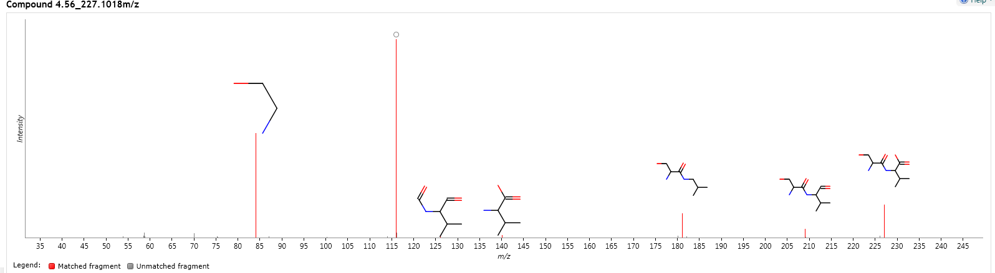
Fig.M1. Fragment match of metabolites of 4.56_227.1018m/z

